Bryanna Hardy

ARM Assembly

**Part A**

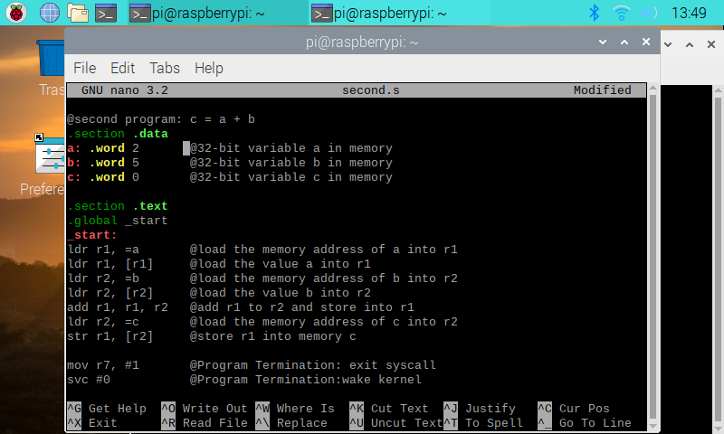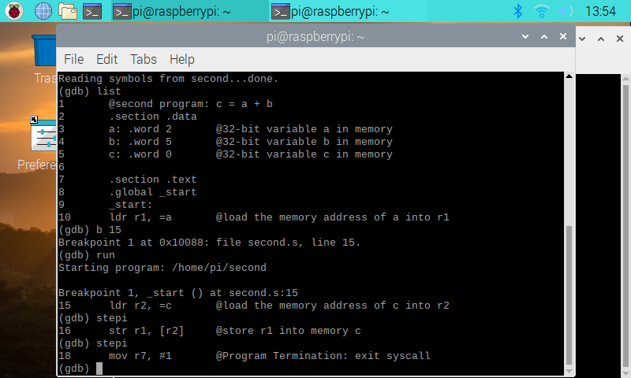

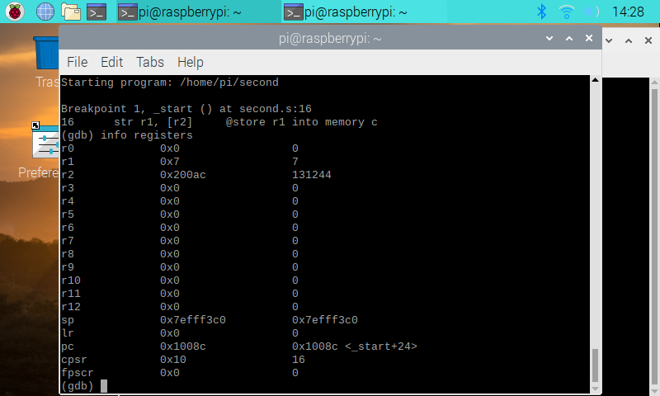

These images above are from the tutorial of the ARM Assembly. It taught me how to load the memory into the register(s) from using the variables that are already from the .data. This is a little bit different than coding in Intel x86. The tutorial instructed me to basically add two variables and load/store it into another variable. As you can see, in the first image, I loaded each variable into a register and once I did that, I added the two registers that hold the variables a and b, which gives you the sum of 7. Then, I store the sum into r1 and as you can see in the third image, you can see the sum stored into that register.

**Part B**

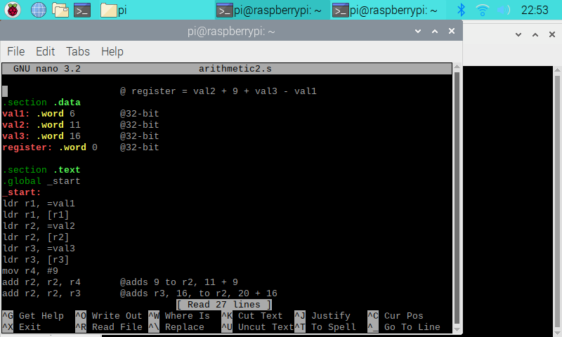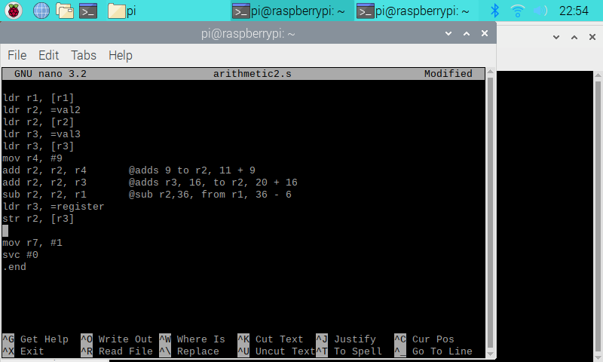

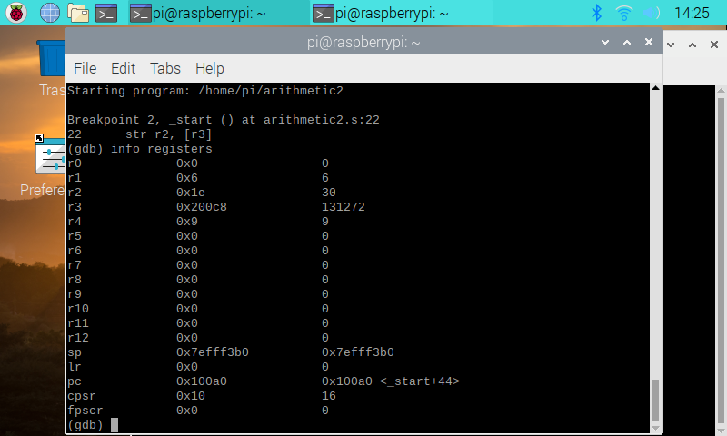

These images are from Try It On Your Own in ARM Assembly. I used the tutorial as a template to help me create this program. As you can see, I had to code an equation, register = val2 +9 + val3 - val1. To do so, I stored each variable with a value in the .data. Once I completed that, I loaded and stored each variable into a register. After that, I added the immediate value to register 2, and then I added r1 to r2. Then, I loaded the variable register into r3, and stored the r3 into r2. In the last image, you can see that r2, has the correct answer, 30.